Password Strength Evaluation Report

Objective
Understand what makes a password strong by evaluating multiple passwords of varying complexity against common password strength criteria (similar to tools like PasswordMeter) and summarizing best practices.

Methodology
- Created passwords with increasing complexity (length, character sets, randomness).
- Evaluated each against common strength rules:
  - Length (8–16+ characters)
  - Uppercase, lowercase, numbers, symbols
  - Penalties for repetition, sequences, dictionary words
- Recorded estimated score (0–100) and qualitative feedback.

Password Tests & Results

password
- Strength Rating: Very Weak
- Estimated Crack Time: Less than a second
- Explanation: This password is a common dictionary word with no uppercase letters, numbers, symbols, or sufficient length. Attackers include it in the very first attempts of dictionary and brute-force attacks, making it extremely insecure.
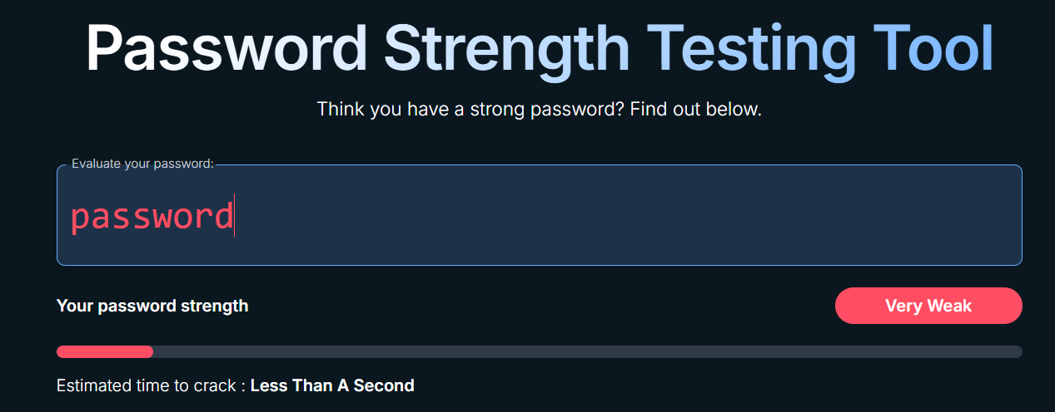

Password1
- Strength Rating: Very Weak
- Estimated Crack Time: Less than a second
- Explanation: Although it includes an uppercase letter and a number, the structure follows a highly predictable pattern (capitalized first letter + number at the end). Password cracking tools are specifically designed to guess such variations quickly.
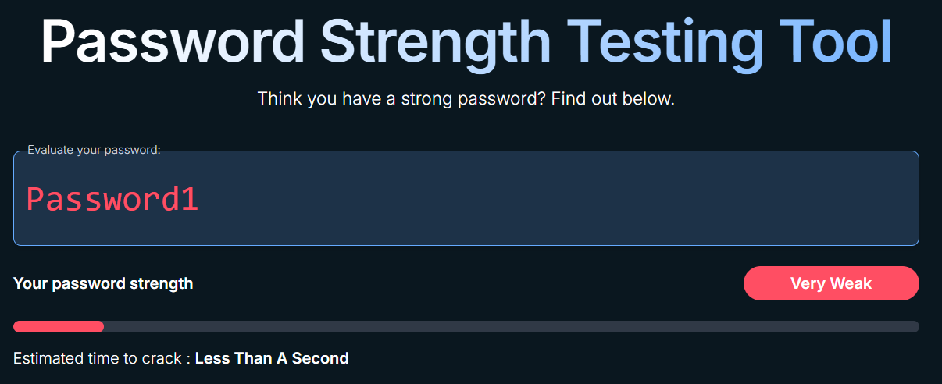

Password1!
- Strength Rating: Very Weak
- Estimated Crack Time: 2 seconds
- Explanation: Adding a symbol slightly increases complexity, but the password is still based on a common word with predictable substitutions. The tool recognizes this pattern and still classifies it as very weak.
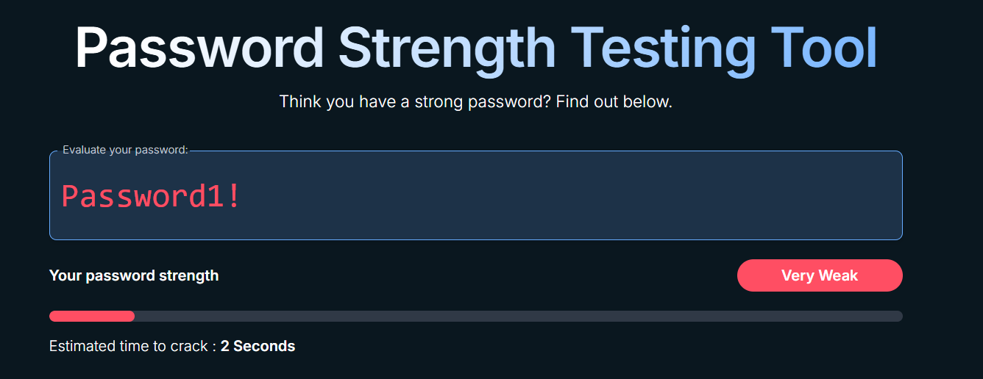

Tr0ub4dor&3
- Strength Rating: Good
- Estimated Crack Time: 4 months
- Explanation: This password includes uppercase and lowercase letters, numbers, and a symbol, significantly improving its strength. However, it is still derived from a recognizable word with substitutions, which reduces its overall security.
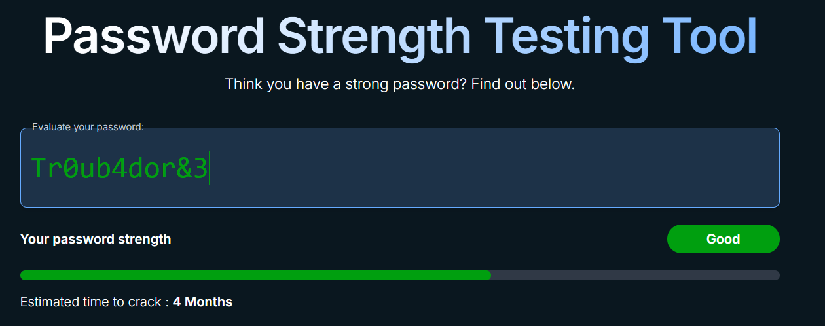

k9!Qz$L2@Wf8
- Strength Rating: Good
- Estimated Crack Time: 3 years
- Explanation: This password appears random and does not contain dictionary words or obvious patterns. The mix of character types and randomness increases entropy, making it far more resistant to brute-force attacks.
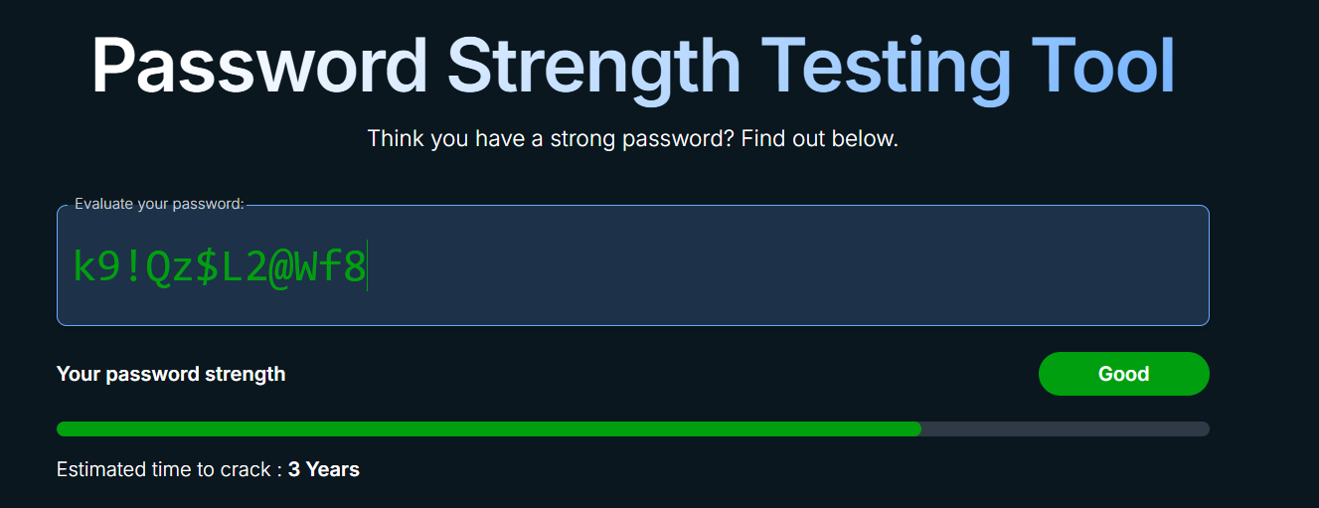

mR7$A!2Z#9cL@4Q
- Strength Rating: Strong
- Estimated Crack Time: Centuries
- Explanation: The password is long, fully random, and uses all character types. There are no detectable patterns, which dramatically increases the number of possible combinations attackers must try.
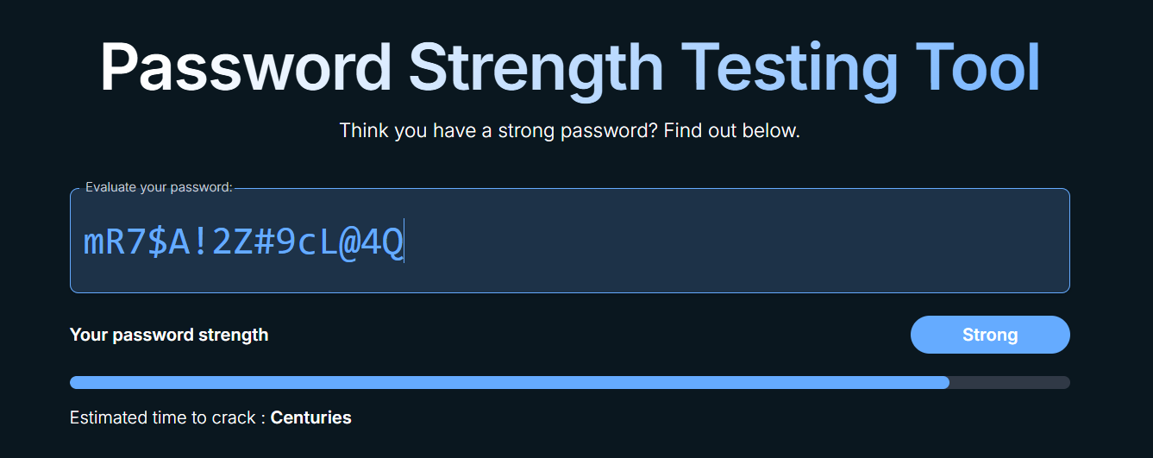

Screenshot 7: correct-horse-battery-staple@37458
- Strength Rating: Strong
- Estimated Crack Time: Centuries
- Explanation: This long passphrase combines multiple words with symbols and numbers. Its length provides very high entropy while remaining memorable, demonstrating why passphrases are considered one of the strongest password strategies.
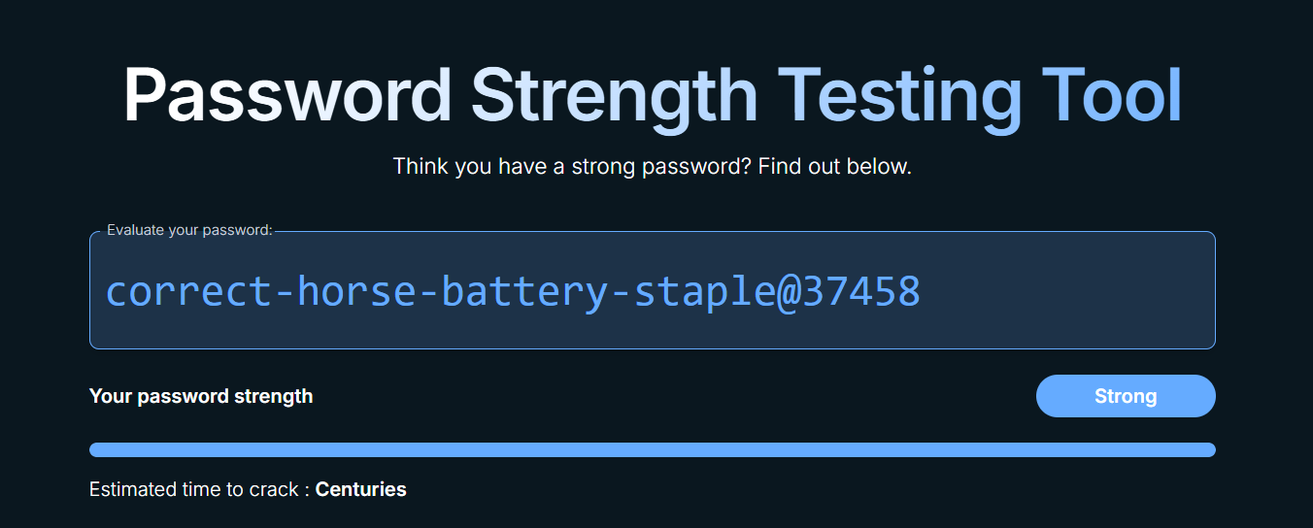

The following results are taken directly from the password strength testing tool screenshots provided. These reflect actual tool feedback, including strength labels and estimated crack times.
# | Password Tested | Tool Strength Rating | Estimated Time to Crack | Explanation
1 | password | Very Weak | Less than a second | Dictionary word, no complexity, extremely common
2 | Password1 | Very Weak | Less than a second | Predictable capitalization and number pattern
3 | Password1! | Very Weak | 2 seconds | Symbol added, but still follows a common pattern
4 | Tr0ub4dor&3 | Good | 4 months | Mixed characters and length, but still word-based
5 | k9!Qz$L2@Wf8 | Good | 3 years | Randomized characters, no dictionary words
6 | mR7$A!2Z#9cL@4Q | Strong | Centuries | Long, fully random, high entropy
7 | correct-horse-battery-staple@37458 | Strong | Centuries | Very long passphrase with symbols and numbers

Best Practices for Creating Strong Passwords
- Length matters most – Aim for 12–16+ characters.
- Use all character types – Uppercase, lowercase, numbers, symbols.
- Avoid dictionary words & names – Even with substitutions.
- Avoid patterns – No seasons, years, keyboard walks, or repeats.
- Prefer randomness or passphrases – High entropy is key.
- Unique per account – Never reuse passwords.
- Use a password manager – Enables long, random passwords

Tips Learned from the Evaluation
- Adding a symbol to a weak password helps only slightly.
- Predictable substitutions (@ for a, 3 for e) are easily detected.
- Long passphrases can outperform short complex passwords.
- Randomness beats complexity tricks.

Common Password Attacks

1. Brute Force Attack
- Tries every possible combination.
- Defense: Long passwords and mixed character sets increase search space exponentially.

2. Dictionary Attack
- Uses common words and leaked password lists.
- Defense: Avoid real words; use randomness or passphrases.

3. Credential Stuffing
- Uses leaked passwords on multiple sites.
- Defense: Unique passwords + MFA.

4. Rainbow Table Attack
- Uses precomputed hashes.
- Defense: Strong hashing + salts (system-side), long passwords (user-side).

Impact of Password Complexity on Security

Higher complexity and length = higher entropy.

Increased entropy makes brute force attacks computationally expensive.

Complex, unique passwords reduce risk from automated attacks.

Passwords combined with multi-factor authentication (MFA) provide the strongest protection.

Conclusion

Password strength is determined by length, randomness, and character diversity. Testing passwords with strength checkers demonstrates that long, unique, and random passwords provide the best defense against common password attacks.

